Integrating Quantum Computing with Artificial Intelligence: A Physics-Inspired Framework for Technological Advancement in India
Gurraunak Singh Bedi Kings Collage London. London, United Kingdom ronkie.bedi@gmail.com
Saransh Sabharwal Vivekananda Institute of Professional Studies, GGSIP University, Delhi, India sabharwalsaransh@gmail.com

Abstract
The fusion of quantum computing (QC) and artificial intelligence (AI) is one of the most fundamental changes in current-day computation with the capability to get around the physical and algorithmic limits of classical systems. This review paper discusses the dynamic intersection point of these two fields using a framework of physics-based concepts, in which quantum concepts of superposition, entanglement, and interference are implemented to improve learning, optimization, and data processing. The study summarizes ten principal works involving Quantum Neural Networks (QNNs), Quantum Support Vector Machines (QSVMs), Reservoir Computing, and Quantum Approximate Optimization Algorithms (QAOA) by reviewing the current developments in the field in theoretical, algorithmic, and applied research. Results show that in spite of the fact that quantum-AI integration can be better scaled, model nonlinearity and make probabilistic decisions, hardware stability, data encoding, interpretability, and interdisciplinary implementation remain challenging. Research gaps that are critical as identified by the review include gaps in standardized benchmarking, no quantum-ready datasets, and no unified theoretical framework that links quantum mechanics with statistical learning theory. Particular attention is paid to the role of the emerging of India in this ecosystem, with the National Quantum Mission (NQM, 2023-2031) and the work of IIT Madras, IISc Bangalore, and C-DAC putting the country in the position to become a regional quantum-AI research and education hub. The paper concludes by saying that combining QC and AI is not a technological development or even a conceptual development but a conceptual development - reinventing computation as physical learning. Placing this synthesis in the context of the current technological and academic environment in India, the review identifies one of the avenues of creating a quantum-literate and AI-driven innovation layer in the next decade.
Keywords
Quantum Computing, Artificial Intelligence, Quantum Machine Learning, Quantum Neural Networks, Hybrid Algorithms, Quantum Support Vector Machines, National Quantum Misson, Technological Advancements, India

Introduction
One of the most revolutionary changes in computational science is the rising pace of merging quantum computing (QC) and artificial intelligence (AI). The classical systems with their transistor miniaturization and thermodynamic limitations are no longer able to support the growing exponential data consumption and algorithmic complexity requirements of modern AI. Meanwhile, quantum mechanics, which was traditionally seen as the workhorse of microscopic physics, has become a useful computational model that makes use of superposition, entanglement and interference as a means to manipulate information in very new ways. The two have led to the Quantum Machine Learning (QML)(Tychola et al., 2023) and Quantum Artificial Intelligence (QAI) where not only performance in terms of functionality is likely to be enhanced, but also the classical idea of intelligence as an algorithm is challenged. Initial writings by (Schuld, 2019) characterized the mathematical invariance between Hilbert-space quantum states and machine learning feature spaces and showed that data can be encoded as quantum states, and their inner products create quantum kernel space. This was later generalized in (Guntuka, 2024) and (Hullurappa, 2024) and Quantum Neural Networks (QNNs), Quantum Support Vector Machines (QSVMs) and hybrid Variational Quantum Circuits (VQCs) were introduced, where quantum evolution is applied to map features and classical optimization techniques are applied to parameters(Nguyen et al., 2024). It has enormous potential ramifications in India, in accordance with national initiatives, such as the National Quantum Mission (NQM, 2023-2031) and Digital India, which aim to transform India into a model of advanced computing on the planet. Even research institutions like IISc Bangalore, IIT Madras and C-DAC are now developing quantum enhance AI models and hybrid clouds. Such programs demonstrate that leaping in technology can be experienced in India through such a multidisciplinary collaboration of physics, computer science and engineering. Theoretically, this review can be said to have followed a physics-inspired approach, considering the similarity in the mathematical and dynamical aspects of both quantum systems and learning algorithms. In quantum mechanics, a system of particles will run towards a minimum energy state on the Schrodinger equation; in AI, a learning model will run toward a minimum loss on gradient descent. This structural analogy, which learners and physical evolution are the realization of the same optimization principle, implies that computation in itself is a physical process. Even though there is swift development, there are still some critical issues. Quantum hardware is currently in the Noisy Intermediate-Scale Quantum (NISQ) phase with a small number of qubits and high levels of decoherence. There are other obstacles to big data deployment including data encoding, error correction and interpretability. Moreover, ethical and infrastructural considerations should be taken to the fore so that there is fair access to emerging quantum-AI technologies in the Indian setting. The purpose of this review is to gather the existing literature on quantum-AI integration, which connects the global theoretical development with the changing technological perspective of India. Placing quantum intelligence in the context of both physics and national innovation, the paper aims to give an outline of a consistent direction of creating a quantum-literate, AI-driven ecosystem to the future of India.
Literature Review
1. Theoretical Foundations of Quantum–AI Integration
The idea behind quantum mechanics and artificial intelligence (AI) is based on the similarity in mathematical framework of the two fields. Hilbert spaces are the spaces of evolution of quantum systems, and many machine learning models, in particular, those based on kernels, are also defined in vector spaces, where data similarity is determined by inner products. This correspondence is expressed in (Schuld, 2019) by describing machine learning as a process operating in quantum spaces where data points can be modeled and measured as quantum states and quantum kernels are used to measure the overlap between data points.
$$K(x_{i},x_{j})=∣⟨ψ(x_{i})∣ψ(x_{j})⟩∣^{2}$$
This mapping enables machine learning algorithms to take advantage of the exponentially large feature space of quantum systems. The theoretical connection between the two was further extended in (Ayoade et al., 2022) to the concept of quantum-inspired computation, or algorithms that attempt to implement quantum parallelism on a classical architecture with a long-term goal of implementing them on quantum machines. Their publication recommended that quantum calculations have the capability to re-represent the data form where binary logic is substituted with the probability amplitude distributions, which are naturally consistent with statistical learning frameworks. These insights were combined (Hullurappa, 2024) by considering AI-QC integration as the extension of computational physics. He developed a physics-motivated computational model where AI loss minimization is analogous to quantum system energy minimization. This analogy,
$$\underset{θ}{min⁡}L(θ)↔\underset{∣ψ⟩}{min⁡}⟨ψ∣\hat{H}∣ψ⟩,$$
positions quantum-AI integration not as a hybrid technology, but as a single physical process of learning and evolution. Collectively, the works of these theorists establish the mathematical and philosophical basis of the field computation as physical evolution, learning as the transformation of a state, and intelligence as the emergent property of the quantum dynamics of information.
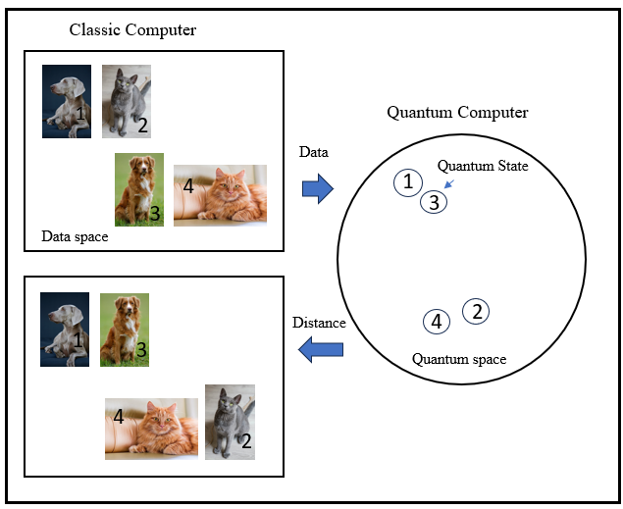
Figure 3 - Classical vs quantum feature space representation. In quantum computing, data points are encoded as quantum states whose inner products define quantum kernels (adapted from Schuld, 2019).
2. Algorithmic Progress and Hybrid Quantum Learning Models
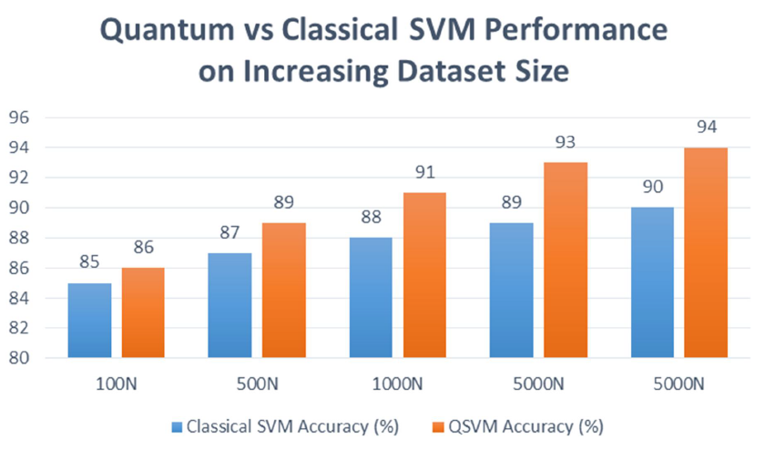
Quantum circuits with classical optimization have been the motivation behind the transition of theory to practical implementation due to the emergence of Quantum Machine Learning (QML) algorithms. A detailed taxonomy of such models was given in (Guntuka, 2024), with the Quantum Support Vector Machine (QSVM) and the Quantum Neural Network (QNN) being key foundational models(García et al., 2022). The QSVM uses quantum kernels calculated by using state overlaps and it shows an acceleration of polynomials to exponential speed in feature-space computations. In the meantime, QNNs simulate neuron activation in unitary transformations on qubits, enabling networks to scale exponentially through large Hilbert spaces.(Abbas et al., 2024) took this algorithmic discussion further by introducing the Physical and Quantum Reservoir Computing (QRC). Their view showed that not only quantum physical systems, such as turbulence in fluids or vibrations in materials, but also non-quantum physical systems can be analog reservoirs of AI computation. They suggested that even richer dynamics (exploited by superposition and entanglement) in quantum reservoirs may be used to provide even onboard AI systems in autonomous vehicles and drones. Both authors arrive at the concept of hybrid architectures, in which quantum subsystems are used to perform high-dimensional mapping and classical optimizers are used to fine-tune.

Graph 1 - Comparative performance of classical SVM and Quantum SVM (QSVM) across increasing dataset sizes, highlighting scalability advantages of quantum kernel computation (adapted from Guntuka, 2024).
model parameters. These systems are particularly strong during the Noisy Intermediate-Scale Quantum (NISQ) epoch, where noise resistance is an important aspect. They do note the limitations, however, thus: little numbers of qubits, error propagation, and training instability through measurement collapse. These contributions, together, denote the algorithmic maturity of the field: The replacement of strictly conceptual analogies with operationalizable models with provable but nevertheless niche-based benefits over classical AI systems.
3. Applied Domains of Quantum–AI Integration
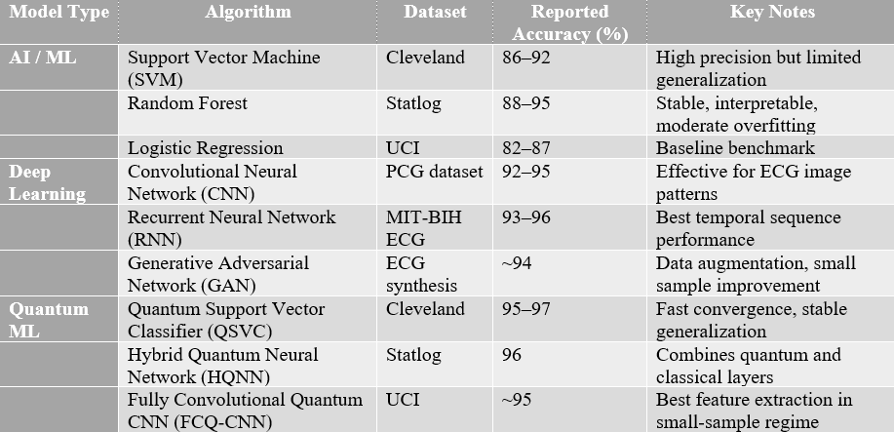
Healthcare and Biomedical Systems

Table 1 - Comparative diagnostic accuracies of traditional AI, Deep Learning (DL), and Quantum Machine Learning (QML) models across benchmark datasets (Fusion Journal, 2023).

The (Computer Science Department, College of Computer Science Information Technology, University of Anbar, Anbar, Iraq et al., 2023) and (Mallow et al., 2022) are helpful to gain a considerable amount of knowledge about quantum-enhanced healthcare AI. The article by Mallow that examined the use of quantum-inspired algorithms on spine data analytics showed that quantum-inspired algorithms could handle large MRI data sets with less computational effort and increased classification accuracy. Equally, the Fusion Journal article provided a thorough comparison between AI, Deep Learning (DL) and QML methods of heart disease diagnosis. It tabulated performance on large datasets including Cleveland, State log, and UCI and it was found that QML classifiers (e.g., QSVC, HQNN) always reached [?]95% accuracy, which was better than most classical models. Nevertheless, these applications are still a show of concept since there is a lack of data, hardware accessibility challenges, and restrictions imposed by ethical concerns regarding the sharing of medical data. Both articles focus on the necessity of hybrid cloud-based quantum computing in the health sector- enabling quantum-assisted diagnosis with classical interpretability.
Cybersecurity and Encryption.
One of the most organized analyses of AI and QC related to cybersecurity is given by (Shoumya Singh & Deepak Kumar, 2024). They demonstrate that quantum computing is an existential threat to RSA and ECC encryption (through the Shor algorithm), but also makes post-quantum cryptography (PQC) and Quantum Key Distribution (QKD) systems (based on the Heisenberg uncertainty principle) possible. They also suggest the AI-enhanced cryptography, in which machine learning will dynamically change the encryption parameters according to the threat analytics. The joint AI-Quantum threat detection architecture and mitigation workflow is described in figures in their paper (in particular, Figure 2 and Figure 3), which can visually be scaled to your paper to show the defensive synergy of QC + AI(Shuford, 2024).
Quantum-AI Finance and optimization.
(Guntuka, 2024) revisited optimization and financial modeling in terms of the Quantum Approximate Optimization Algorithm (QAOA). QAOA uses quantum superposition to search a set of states concurrently and finds near-optimal solutions to NP-hard problems, including portfolio optimization and traveling salesman routes. These are some of the examples demonstrating the practical advantage of QML in areas of combinatorics that are difficult to solve by classical methods.
In the field of the Autonomous and Embedded Systems.
(Abbas et al., 2024) are the first to generalize QML to physical onboard computation i.e. mechanical, acoustic and quantum reservoirs as real-time AI substrates. Their Figure 3-10 gives a graphical map of this new hardware frontier. In the case of your paper simplified versions of Figure 1 of Reservoir Concept and Figure 8 of Spin-Network QRC would be useful in demonstrating how physics itself computes.
Transversal Testing Problems in Implementation Studies.
4. Emerging Gaps and Research Trajectories
Challenges common to all applied papers are: Qubit noise and decoherence, particularly in high-depth circuits.
Bottlenecks in the encoding of data into quantum states - how to encode classical inputs into quantum states using minimal resources.
Interpretability - converting the probabilistic results into interpretable results.
These themes naturally lead to the next theme, Challenges and Limitations.
Outsourcing of Proximality and Novel Gaps and Research Pathways.
In the reviewed literature, a number of similar research gaps are evident:
Hardware constraints: Existing systems can hardly scale to 100 qubits with coherence times in the microsecond range.
Algorithmic benchmarking: There are not many standardized metrics used to compare the QML models with the classical baselines.
Data availability: In medical and security applications, particularly, appropriate quantum-ready data are not easily available.
Arguments on energy efficiency: Although quantum algorithms have the theoretical benefits, experimental energy costs (cooling, error correction) are not studied in depth.
Interdisciplinary knowledge: most of the research in the field of QML is plagued with a lack of cross-domain fluency: physicists are not trained in ML, and computer scientists do not use quantum physics as effectively as they should.
These voids emphasize the necessity of hybrid education and open datasets and standardized testing protocols, which preconditions the global and Indian quantum research ecosystems both.
5. The Indian Quantum–AI Research Landscape
While most reviewed literature originates from global collaborations, (Menon & Adhikari, 2023) present the first detailed academic survey of India’s quantum computing ecosystem. Their analysis traces India’s progress from early-stage quantum theory research to the National Quantum Mission (NQM, 2023–2031), a $1 billion program under the Department of Science and Technology. The NQM emphasizes quantum computing, communication, and materials research, with milestones including the construction of 50-qubit indigenous quantum systems by 2026.
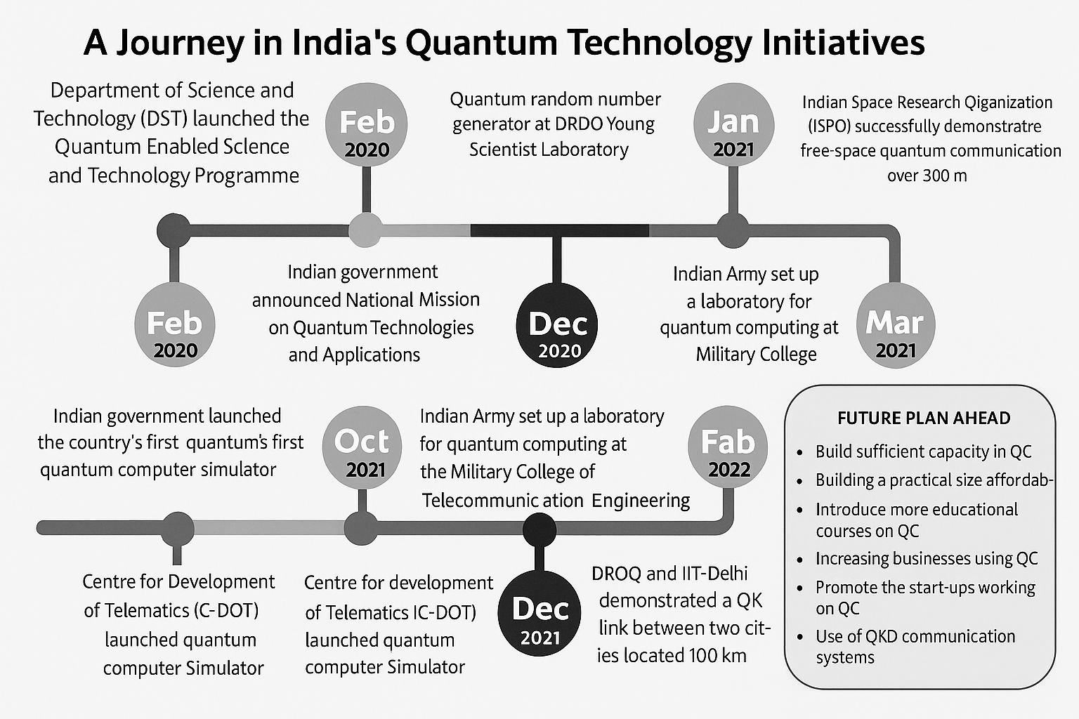
Figure 4 - Major institutions and initiatives shaping India’s national quantum computing and AI ecosystem (Menon & Adhikari, 2023)

Menon and Adhikari highlight India’s unique quadruple-helix model:
- Academia: IIT Madras, IISc Bangalore, TIFR, IISER Pune.
- Industry: C-DAC, IBM Quantum Network India, AWS Quantum Cloud.
- Defense: DRDO’s quantum communication and cryptography labs.
- Policy & Education: Quantum curriculum integration and national fellowships.
They identify similar challenges to those found in global literature—hardware constraints, talent shortages, and coordination gaps—but emphasize India’s human capital advantage and rapid academic adoption. Incorporating this paper allows your review to contextualize India not as a policy actor but as an emerging scientific hub, poised to translate global advances in Quantum–AI integration into indigenous technological development.
Challenges and Research Gaps
Despite the blistering rate of development, quantum computing (QC) and artificial intelligence (AI) also have several long-term issues that would hamper the deployment of these technologies on a large scale. The hardware limitations, algorithm maturity, data bottlenecks, interpretability, and the need to work more interdisciplinarity are these challenges (Shuford, 2024).
- Hardware and Technological Limitations: The state-of-the-art quantum devices currently are in the Noisy Intermediate-Scale Quantum (NISQ) regime with less than 100 qubits with low-coherence times and high gate errors. Although hybrid architecture, like QNNs, QSVMs, or QAOA, is a promising architecture, it is highly dependent on simulators or small-scale prototypes. Error correction is difficult to stabilize in large scale quantum learning models although the concept of error correction is resource-intensive and theoretically motivated(Wang & Liu, 2024).
- Limitations to Algorithms and Computation: Quantum-AI algorithms remain a research area, with no standard benchmarks on which to compare their fair performance. All the studies employ different datasets and noise models, which lead to inconsistency in findings. In addition, there is a lack of proper theoretical basis to match that of classical learning theory. Encoding of data (classical inputs into quantum states) is a challenge that is not yet solved, and it usually dictates the possibility of real quantum advantage.
- Data and Interpretability Gaps: The majority of QML applications are based on small well-curated datasets that do not reflect the variability in the real world. There are few datasets that are quantum-ready, and outputs of probabilistic models are hard to interpret. As an issue, especially one that involves critical part of the system, such as cybersecurity and healthcare, this quantum black box problem raises ethical and trust issues.
- Interdisciplinary and Infrastructural Barriers: There still exists a considerable expertise gap between physicists, computer scientists and engineers. In India, there are few fabrication centers and the basic quantum courses, which compound the development. Despite attempts such as the National Quantum Mission to close this divide, the integration and capacity building in the world is necessary.
- Summary of Research Gaps: The main areas of gaps are poor hardware scalability, no formal quantum learning theory, no standardized datasets, poor interpretability, and not well-coordinated collaboration. It requires a long-term global collaboration, coherent models and integrative educational models, bridging physics and computer science, to develop quantum AI research, concept to practice.
Future Directions
The second phase in quantum and AI integration will rely on tackling physical, computational, and infrastructural problems and transforming the theory into practical systems. The studies of the next generation must be on scalability frameworks, hybrid models and multi-disciplinary integration, in line with the National Quantum Mission (NQM) in India. At the hardware level, hardware should be focused on noise tolerant quantum gates and error tolerant architecture. Some of the innovations that hold a high potential in enhancing coherence, and stabilizing mid-scale processors include topological qubits, bosonic error correction as well as cryogenic photonic circuits. At the same time, the presence of more quantum cloud service and systems like IBM Q and AWS Bracket and national networks in India will also make experimentation accessible and accelerate the benchmarking of Quantum Machine Learning (QML) algorithms. In the algorithmic front the research should develop to quantum frames and domain optimum quantum frames. Hybrid strategies, quantum kernel estimation using classical gradient optimization, will dominate the NISQ era, and the research in the long-run ought to focus on what would appear as the creation of fully quantum neural networks capable of adaptive learning. Establishing common specifications and quantum ready data, which in this case is healthcare, cybersecurity and climate analytics, will be very important in terms of validation and scaling(Ajagekar & You, 2022). Quantum computing with AI and national research policy is a particular opportunity of technological leadership in the case of India. Within the context of NQM, IIT Madras, IISc Bangalore, TIFR, and C-DAC can evangelize under the title of innovation centers to develop native processors and hybrid algorithms. In order to convert academic capability to industrial ability, enhancement of quantum education, creation of industry academia partnership, and investment into fabrication capability will help. Lastly, convergence of AI and quantum computing is not merely the computational revolution, but it is a paradigm shift, i.e., learning and evolution on the physical level are inter-woven. It will succeed on the concept of long-term investment, open data ecosystem and the staff of multidisciplinary personnel which can make a difference in transforming quantum intelligence into reality.
Conclusion
The concept of quantum computing and artificial intelligence implies a paradigm shift in the definition of computation: it is an object that brings together the idea of physical law and the theory of learning. In the literature reviewed, a definite trend can be observed: starting with the theoretical correspondence of quantum mechanics and machine learning through the development of hybrid frameworks, including QNNs, QSVMs, and quantum reservoir systems. The given developments prove that learning may be considered not only as a statistical process but as a quantum evolution of information states as well. Although significant advances have been made, a set of issues (including small number of qubits, noise variability, data codec inefficiencies, and interpretability) still limit large-scale application. However, the physics-motivated framework is providing a consistent map: quantum systems, as they move towards minimal energy states, have AI models become optimal loss landscapes. This symmetry of structures encourages the reunion of physicists with computer scientists, between theory, simulation, and application. In India, the National Quantum Mission (NQM) and efforts of IIT Madras, IISc Bangalore, and C-DAC are some of the initiatives that point to the increased interest of the Indian nation in bringing theoretical innovations to practical technologies. The strong aspect of India is its human capital- a mash-up of physics, computer science and data engineering which can contribute to local innovation. Finally, quantum computing and AI convergence, in addition to being a technological breakthrough, is a philosophical shift in the conceptualization of intelligence, matter, and computation, which demands a new form of literacy in which even intelligence is seen as a physical process that can be engineered and ethically implemented.

References

Abbas, A. H., Abdel-Ghani, H., & Maksymov, I. S. (2024). Classical and Quantum Physical Reservoir Computing for Onboard Artificial Intelligence Systems: A Perspective (Version 1). arXiv. https://doi.org/10.48550/ARXIV.2407.04717
Ajagekar, A., & You, F. (2022). Quantum computing and quantum artificial intelligence for renewable and sustainable energy: A emerging prospect towards climate neutrality. Renewable and Sustainable Energy Reviews, 165, 112493. https://doi.org/10.1016/j.rser.2022.112493
Ayoade, O., Rivas, P., & Orduz, J. (2022). Artificial Intelligence Computing at the Quantum Level. Data, 7(3), 28. https://doi.org/10.3390/data7030028
Computer Science Department, College of Computer Science Information Technology, University of Anbar, Anbar, Iraq, Enad, H. G., Computer Science Department, College of Computer Science Information Technology, University of Anbar, Anbar, Iraq, & Mohammed, M. A. (2023). A Review on Artificial Intelligence and Quantum Machine Learning for Heart Disease Diagnosis: Current Techniques, Challenges and Issues, Recent Developments, and Future Directions. Fusion: Practice and Applications, 11(1), 08–25. https://doi.org/10.54216/FPA.110101
García, D. P., Cruz-Benito, J., & García-Peñalvo, F. J. (2022). Systematic Literature Review: Quantum Machine Learning and its applications (Version 2). arXiv. https://doi.org/10.48550/ARXIV.2201.04093
Guntuka, S. (2024). Quantum Machine Learning: Bridging Quantum Computing and Artificial Intelligence. International Journal for Research in Applied Science and Engineering Technology, 12(9), 1455–1460. https://doi.org/10.22214/ijraset.2024.64377
Hullurappa, M. (2024). Uniting Quantum Computing and Artificial Intelligence: Exploring New Frontiers. FMDB Transactions on Sustainable Computer Letters, 2(2), 120–130. https://doi.org/10.69888/FTSCL.2024.000186
Mallow, G. M., Hornung, A., Barajas, J. N., Rudisill, S. S., An, H. S., & Samartzis, D. (2022). Quantum Computing: The Future of Big Data and Artificial Intelligence in Spine. Spine Surgery and Related Research, 6(2), 93–98. https://doi.org/10.22603/ssrr.2021-0251
Menon, V. G., & Adhikari, M. (2023). Quantum computing in India: Recent developments and future. IET Quantum Communication, 4(2), 93–95. https://doi.org/10.1049/qtc2.12056
Nguyen, T., Sipola, T., & Hautamäki, J. (2024). Machine Learning Applications of Quantum Computing: A Review. https://doi.org/10.48550/ARXIV.2406.13262
Schuld, M. (2019). Machine learning in quantum spaces. Nature, 567(7747), 179–181. https://doi.org/10.1038/d41586-019-00771-0
Shoumya Singh & Deepak Kumar. (2024). Enhancing Cyber Security Using Quantum Computing and Artificial Intelligence: A Review. International Journal of Advanced Research in Science, Communication and Technology, 4–11. https://doi.org/10.48175/IJARSCT-18902
Shuford, J. (2024). Quantum Computing and Artificial Intelligence: Synergies and Challenges. Journal of Artificial Intelligence General Science (JAIGS) ISSN:3006-4023, 1(1). https://doi.org/10.60087/jaigs.v1i1.35
Tychola, K. A., Kalampokas, T., & Papakostas, G. A. (2023). Quantum Machine Learning—An Overview. Electronics, 12(11), 2379. https://doi.org/10.3390/electronics12112379
Wang, Y., & Liu, J. (2024). A comprehensive review of quantum machine learning: From NISQ to fault tolerance. Reports on Progress in Physics, 87(11), 116402. https://doi.org/10.1088/1361-6633/ad7f69

